MANDATORY ADA DISCLOSURE ATTENTION: You may be subject to liability for failure to meet your legal obligation to comply with state and federal disability access laws. The recent issuance or renewal of a business license or equivalent instrument or permit does not mean that your business has been determined to be in compliance with state and federal disability access laws.
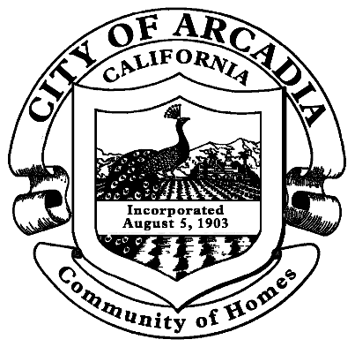
City of
Arcadia

Development
Services
Department

Jason Kruckeberg
Assistant City Manager/ Development Services Director

240 West Huntington Drive
Post Office Box 60021
Arcadia, CA 91066-6021
(626) 574-5415
(626) 447-3309 Fax
www.ArcadiaCA.gov

Please see the attached materials for more information.

ENSURING EQUAL ACCESS TO YOUR BUSINESS

The State of California wants to ensure that all people have equal access to public and private services. Many people with disabilities do not have equal access to services because many business owners do not take the time to ensure that their businesses are accessible. Some common problems disabled people encounter are:

(1) The building has architectural barriers that make it difficult or impossible for someone using a wheelchair, walker, or other mobility device to get inside or move around.

(2) The business uses a website that does not work with screen reading devices and other assistive technology.

(3) The business does not allow people with disabilities to enter the building with their service animals.

(4) The staff do not receive ADA training and do not know about the requirements to modify practices or to provide auxiliary aids and services.

As the operator of a business, it is your responsibility to ensure that your business provides equal access to people with disabilities. Refusing to make your business accessible is discrimination under state and federal law. People with disabilities and the government have the right to sue businesses that discriminate.

The best way to protect yourself from a lawsuit is to make your business accessible. Here are some important steps you should take:

(1) Schedule an inspection with a Certified Access Specialist. A Certified Access Specialist (CASp) is a person who the State of California recognizes as having specialized knowledge of accessibility standards. They can inspect your business and tell you what changes you need to make for your business to be accessible to disabled people. Getting a CASp inspection has important benefits, like giving you extra protection in a lawsuit.

To find a CASp in your area, contact the CASp Program at the Division of the State Architect. You can also visit www.apps2.dgs.ca.gov/DSA/casp/casp_certified_list.aspx. Additionally, you should contact your local government and ask what resources it has to help businesses comply with disability access laws. The State of California makes money available to local governments to create programs that help business owners comply with disability access laws.

(2) Learn about accessibility laws from reliable sources. There is a lot of misinformation about accessibility laws. Get information about your rights and responsibilities as a business owner from reliable, trustworthy sources. California has several agencies that provide fact sheets, trainings, and other educational materials about accessibility. In fact, one of these agencies, the California Commission on Disability Access, was created by the Legislature for the purpose of helping businesses comply with accessibility laws. You should contact the following agencies and ask for information on how to comply with accessibility laws:

The California Commission on Disability Access: www.ccda.ca.gov.

The Division of the State Architect: www.dgs.ca.gov.

The Department of Rehabilitation: www.dor.ca.gov.

(3) Making your business accessible is good for everyone. It makes your business available to more customers. It also promotes fair and equal access. We thank you for doing your part to help make California a great place for everyone!

